CTM-I Use Case

Firm Description

Version 0.1

Use Case Name | Firm Description
Actor | Broker, Firm User, Market Ops, Ops, App Support
Pre-conditions /Assumptions | User has Browser and is aware of the http path to the application.  User has successfully logged into the CTM-I application.  User has the right role to see the menu options.
Post Conditions | None
Screenshot | 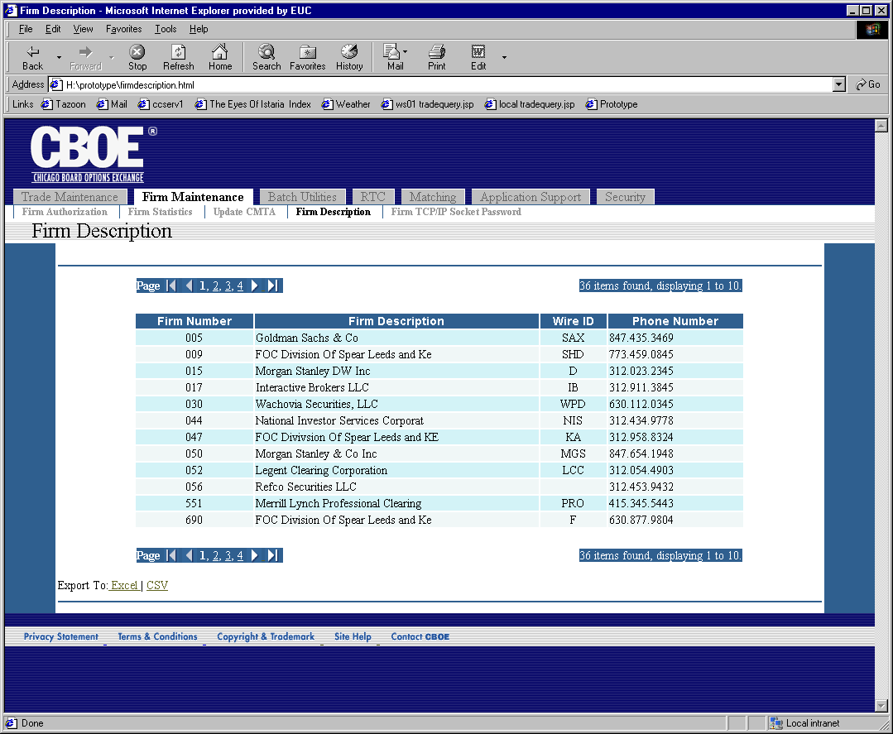
Flow of Events | - User selects “Firm Description” from the menu.  - A request is sent to CTM-R to retrieve the firm data.  - Firm Description screen appears with data.  - All the data related to firm and its description is displayed 10 records at a time. Standard paging is available.  - User will be allowed to export the search results to Excel or in a Comma Separated Values file. The exported data will contain all related data, not limited by the data listed on the screen.
Alternative Path

